Issues/Ideas March 9th:
- Future penalty: 5-year LAG
  - ISSUE: For stratified data: we don’t have enough data points logtituitinaly
We tried 2-year and 3-year lags for stratified data but the distirbution is sparse and wide
    - Let’s put all of the stratified data together (by race, sex) and fit a single distribution for stratified data

- U-TURN: The 5-year ratio of ratios for the U-turn creates too much noise and increase that uncertainty in the final distribution
  - Switch to a moving average and their ration: (average last 5 points)/(average of future 5 points)
  - Or take a linear regression before/after hinge point, and calculate the ratio of slopes
- We don’t have data for U-turn penalty for stratified data

Five-Year Growth and Double-Delta Analysis of Primary/Secondary Syphilis Diagnoses
Methods, Date Ranges, and Assumptions

Overview
This analysis characterizes medium-term syphilis diagnosis dynamics across U.S. metropolitan statistical areas (MSAs) using CDC surveillance data. Two related but distinct metrics are analyzed:
- Five-year backward growth ratio
- Five-year double-delta (growth curvature / acceleration)
Because these metrics have different data requirements, they are estimated over different calendar windows. This distinction is intentional and methodologically necessary.

Data Sources
- Case counts: CDC STI surveillance data
County-aggregated estimates are used when available; otherwise PDF report counts are used.
- Population: U.S. Census annual population estimates
- Geography: Metropolitan Statistical Areas (MSAs)
- Exclusions: National aggregates (“US”)

Analysis Windows (Key Design Choice)

Backward Five-Year Growth Ratio
Calendar window:
2012-2022
This window is selected to:
- Maximize the number of MSAs with complete, high-quality reporting
- Emphasize recent epidemic dynamics
- Avoid excessive attrition from early reporting gaps

Five-Year Double-Delta
Calendar window:
2002-2022
The double-delta requires three observations separated by five years. Formally, it depends on values at:
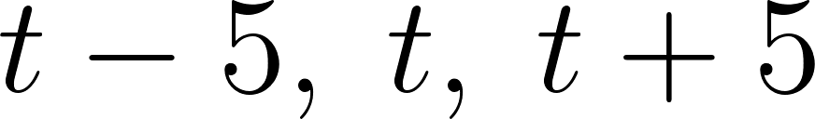
Using a shorter calendar window would sharply reduce the number of usable observations. The longer window is required to characterize growth curvature, not just net change.

CDC reliability rule
All analyses apply the CDC reliability threshold to ensure that observed number of diagnosis in a year is at least
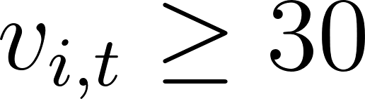
- Backward ratio: required at 
- Double-delta: required at 
This ensures stability of ratios and curvature estimates.

Five-Year Backward Growth Ratio

Definition
For location  and year :
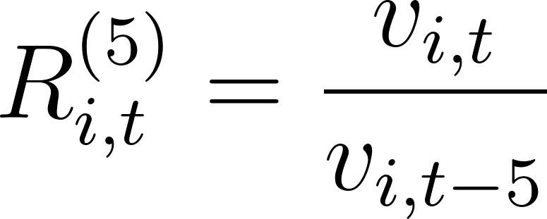

Inclusion Criteria
- 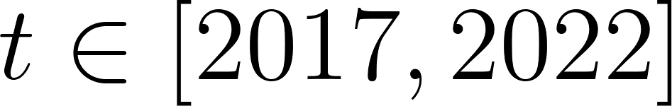
- Complete data for locations with all years 2012-2022
-  and 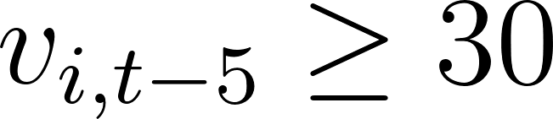
- 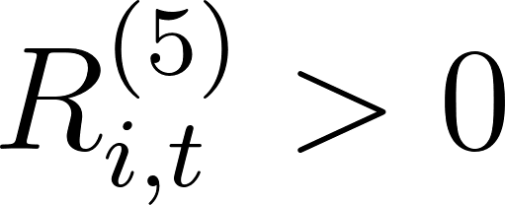
This metric captures net five-year growth without imposing a time trend.

Five-Year Double-Delta (Growth Curvature)

Motivation
The backward ratio measures magnitude of change but not shape. The double-delta quantifies whether growth is accelerating, decelerating, or reversing.

Definition
Let:
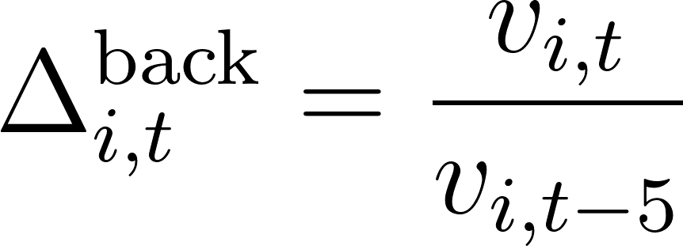

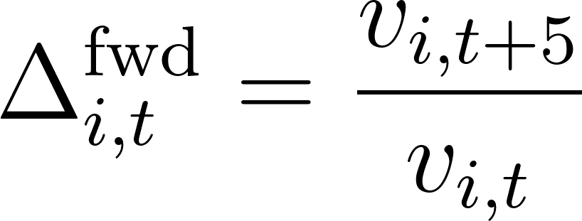
The double-delta is:
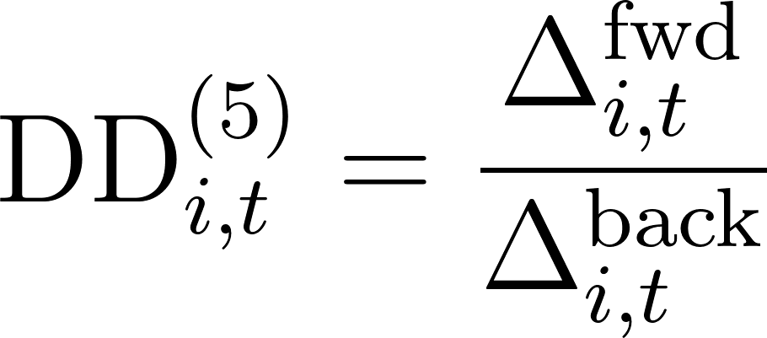

which is equivalent to:

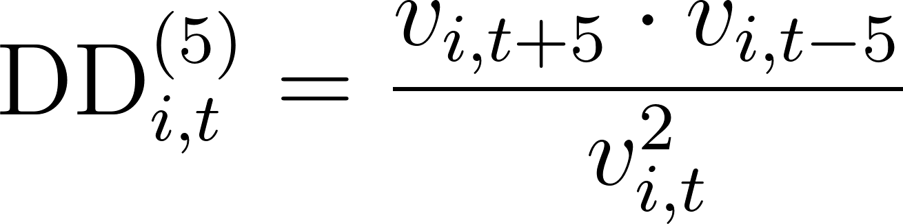

Interpretation
- 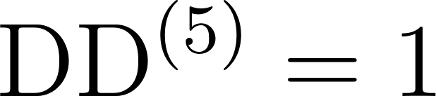 : constant growth
-  : acceleration (upward curvature)
-  : deceleration or reversal (U-turn)

Log Transformation
All ratios are analyzed on the log scale:
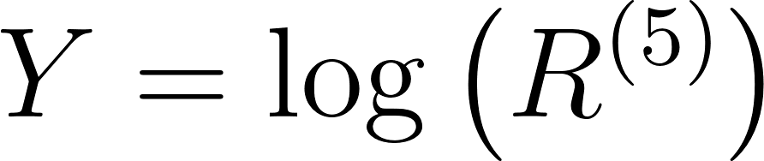
This:
- Centers no-change at zero
- Stabilizes variance
- Justifies lognormal modeling fit (normal distribution fit on log scale)

Outlier Control: Tukey Filtering
Tukey filtering is applied after log transformation:

Two Separate Filters
- Unweighted Tukey: quantiles computed treating all observations equally
- Population-weighted Tukey: quantiles computed using population-weighted empirical distributions
Each filter is applied only to the model it feeds.

Population Weighting
Population weighting reflects average population change over the interval.

Backward Ratio
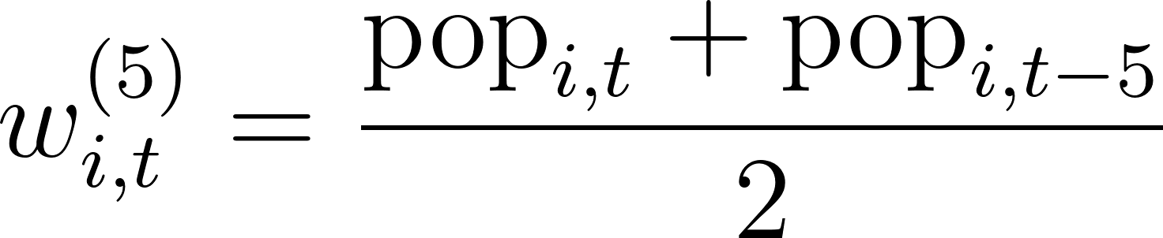

Double-Delta
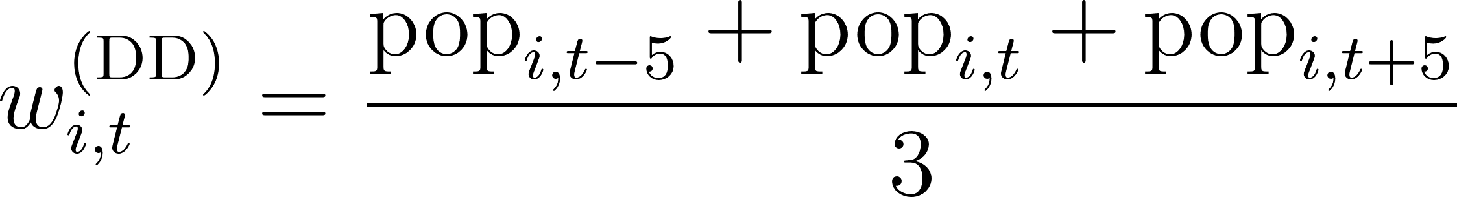

Weights are normalized prior to estimation.

Lognormal Model
For either metric :
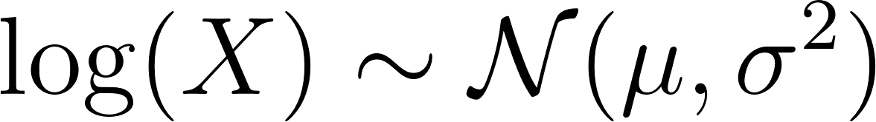

Estimation
- Unweighted:
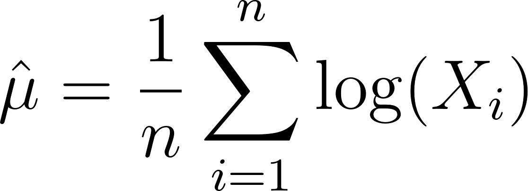

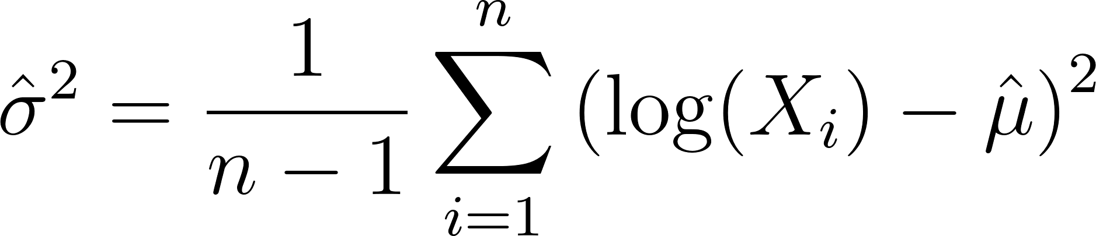

- Population-weighted:
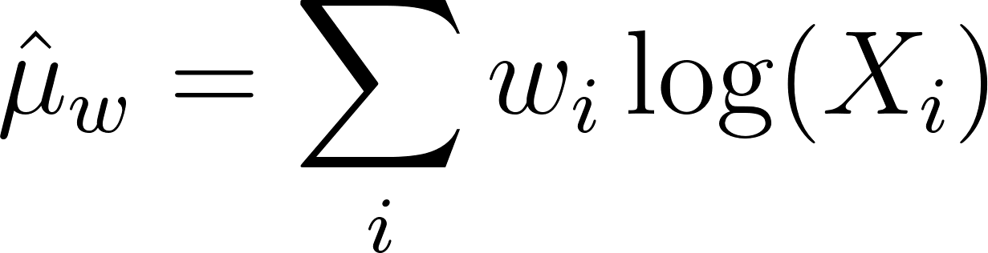

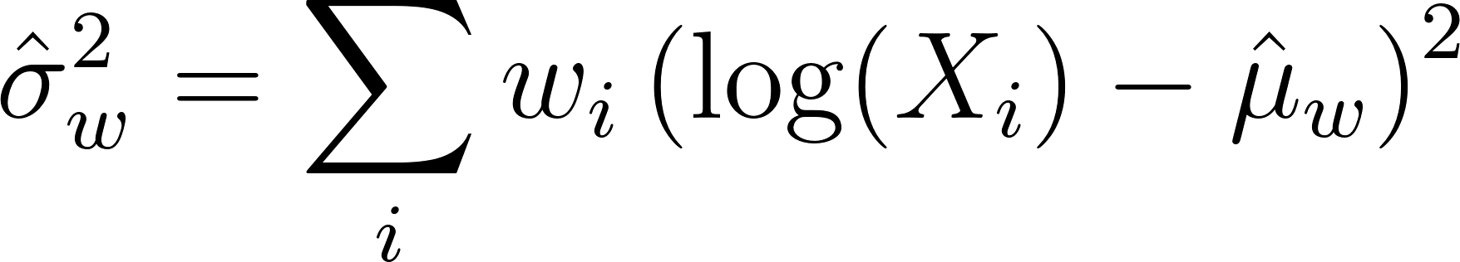

Derived Quantities
- Median: 
- Mean: 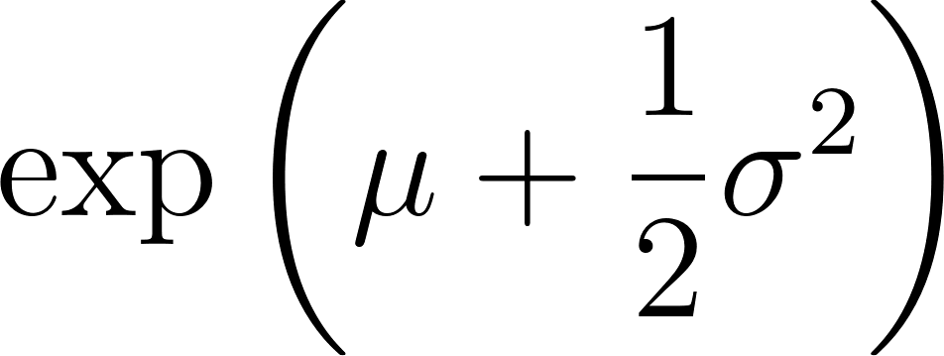
- 95% interval:

Empirical Distribution of Growth Ratios:
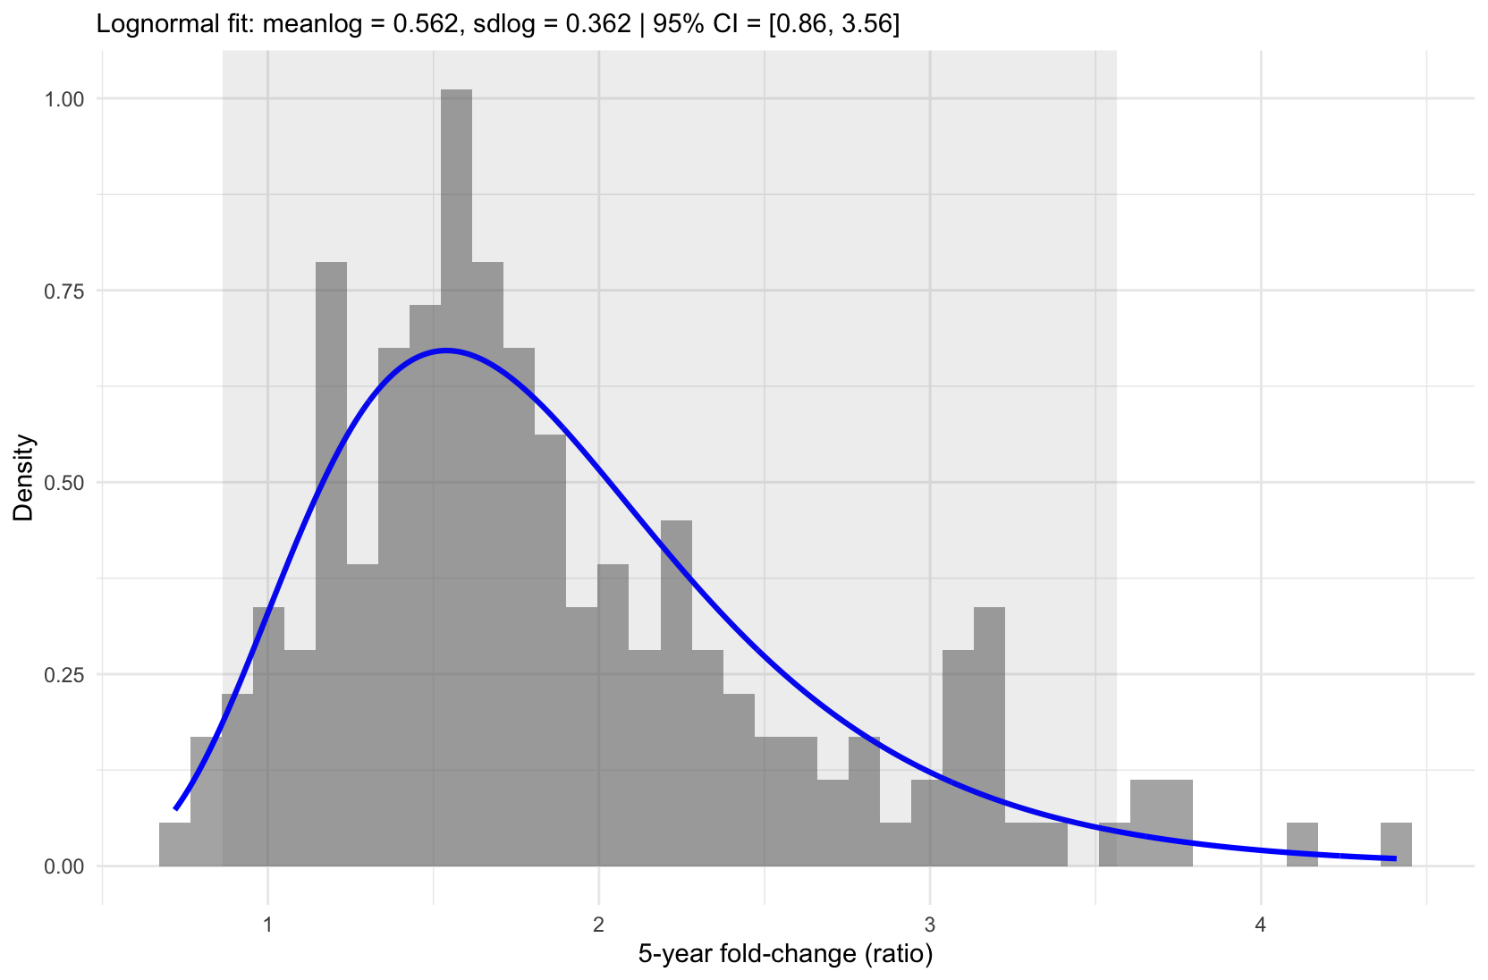
Figure 1. Empirical distribution and lognormal fit of pooled 5-year growth ratios.
Histogram of pooled 5-year backward growth ratios across 32 metropolitan statistical areas with complete data, after Tukey filtering. The solid curve shows the fitted lognormal density (meanlog = 0.562, sdlog = 0.362), with the corresponding 95% reference interval indicated in the subtitle and shaded on the graph in grey. Vertical dashed lines denote the median and selected reference points of the fitted distribution. This empirical fit forms the basis for the reference distribution used in the future-change penalty.

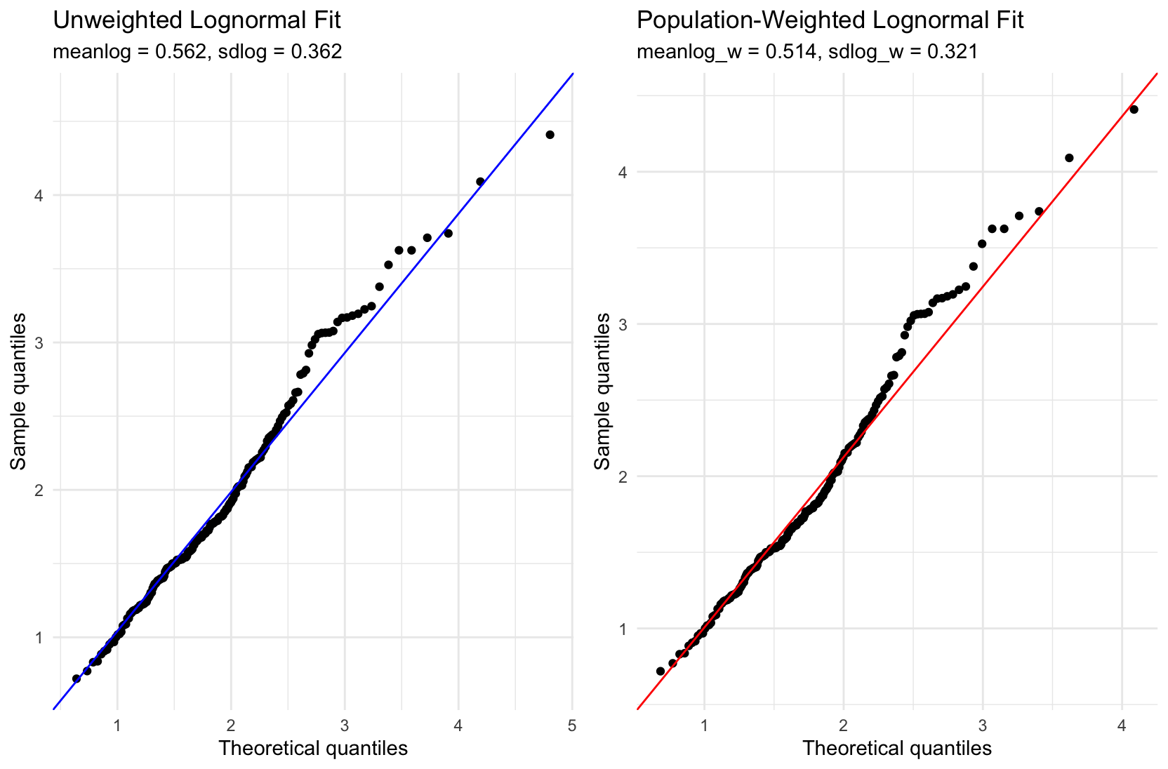
Figure 2. Unweighted and population-weighted lognormal Q–Q plots.
Quantile–quantile plots comparing empirical 5-year backward growth ratios to fitted lognormal reference distributions. The left panel shows the unweighted fit (meanlog = 0.562, sdlog = 0.362), while the right panel shows the population-weighted fit (meanlog = 0.514, sdlog = 0.321). Points denote empirical quantiles and solid lines denote the corresponding theoretical lognormal quantiles. Population weighting shifts the fitted distribution toward lower central tendency and reduced dispersion, reflecting greater influence from larger metropolitan areas.

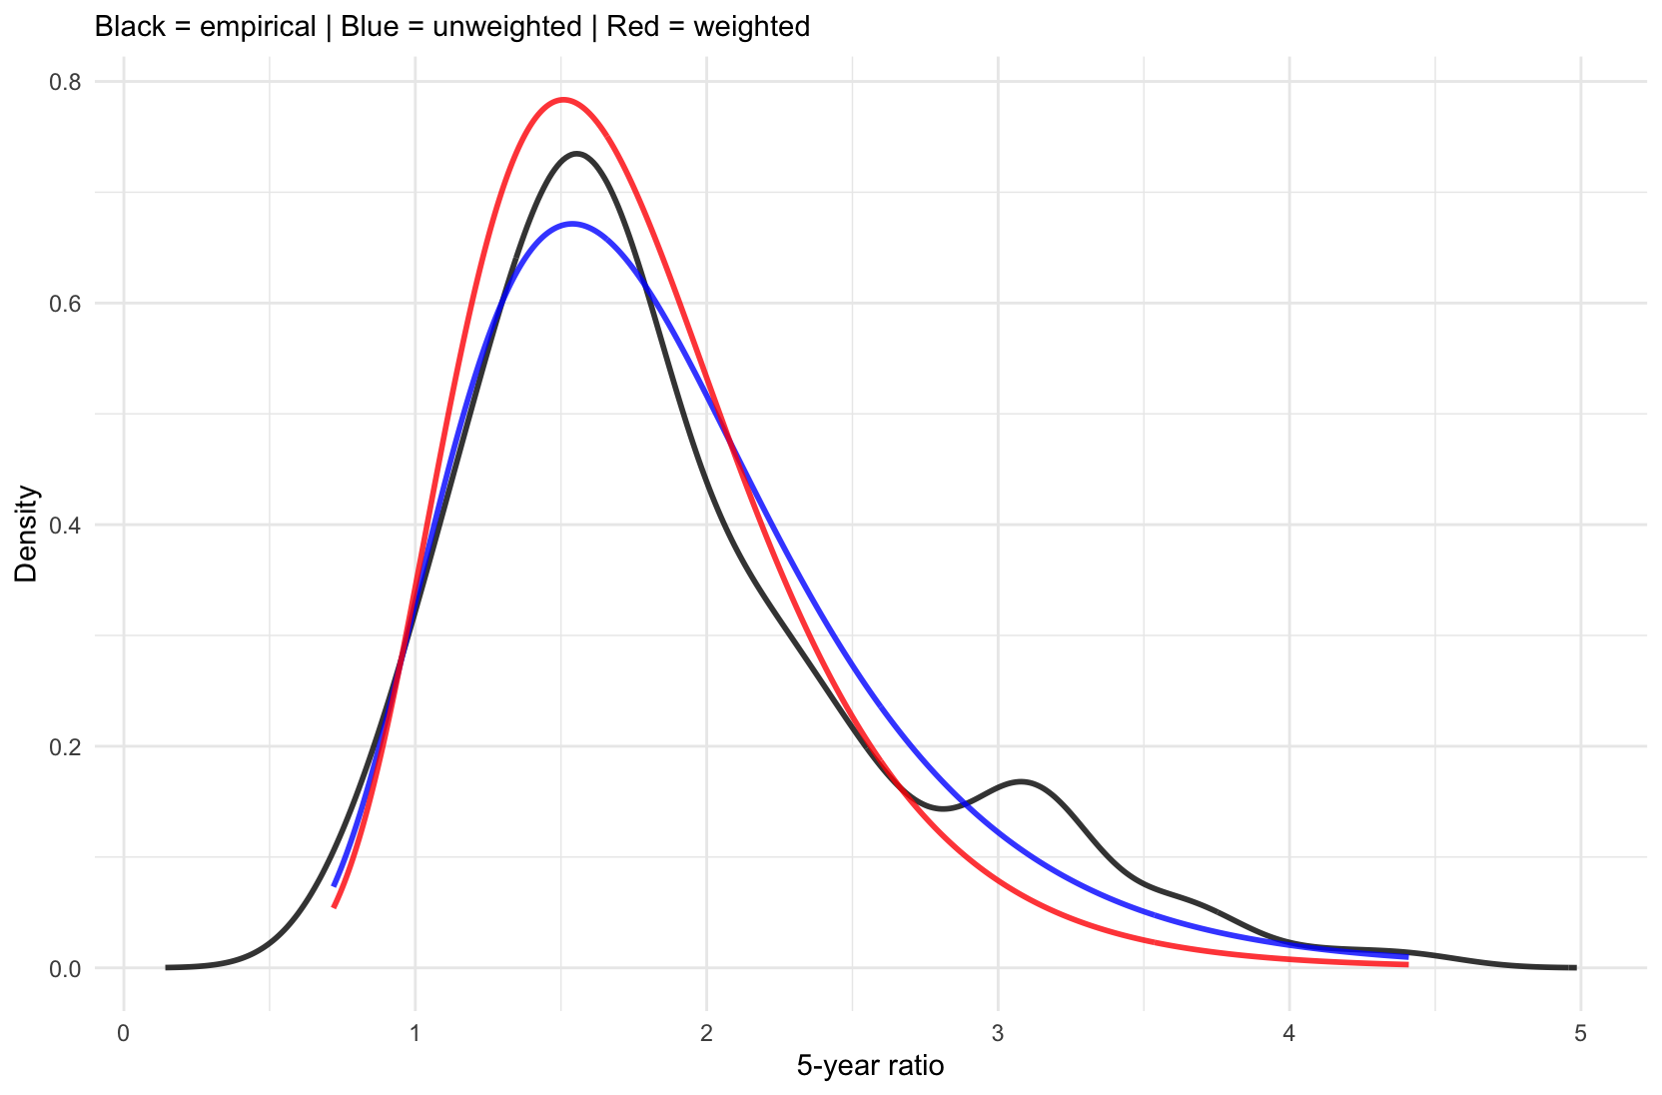

Figure 3. Density comparison of unweighted and population-weighted lognormal fits.
Empirical density of pooled 5-year backward growth ratios (black) compared with fitted lognormal densities under unweighted (blue) and population-weighted (red) estimation. The weighted fit places greater mass near the central region and down-weights extreme tail behavior relative to the unweighted fit.

Empirical Distribution of Double-Deltas:

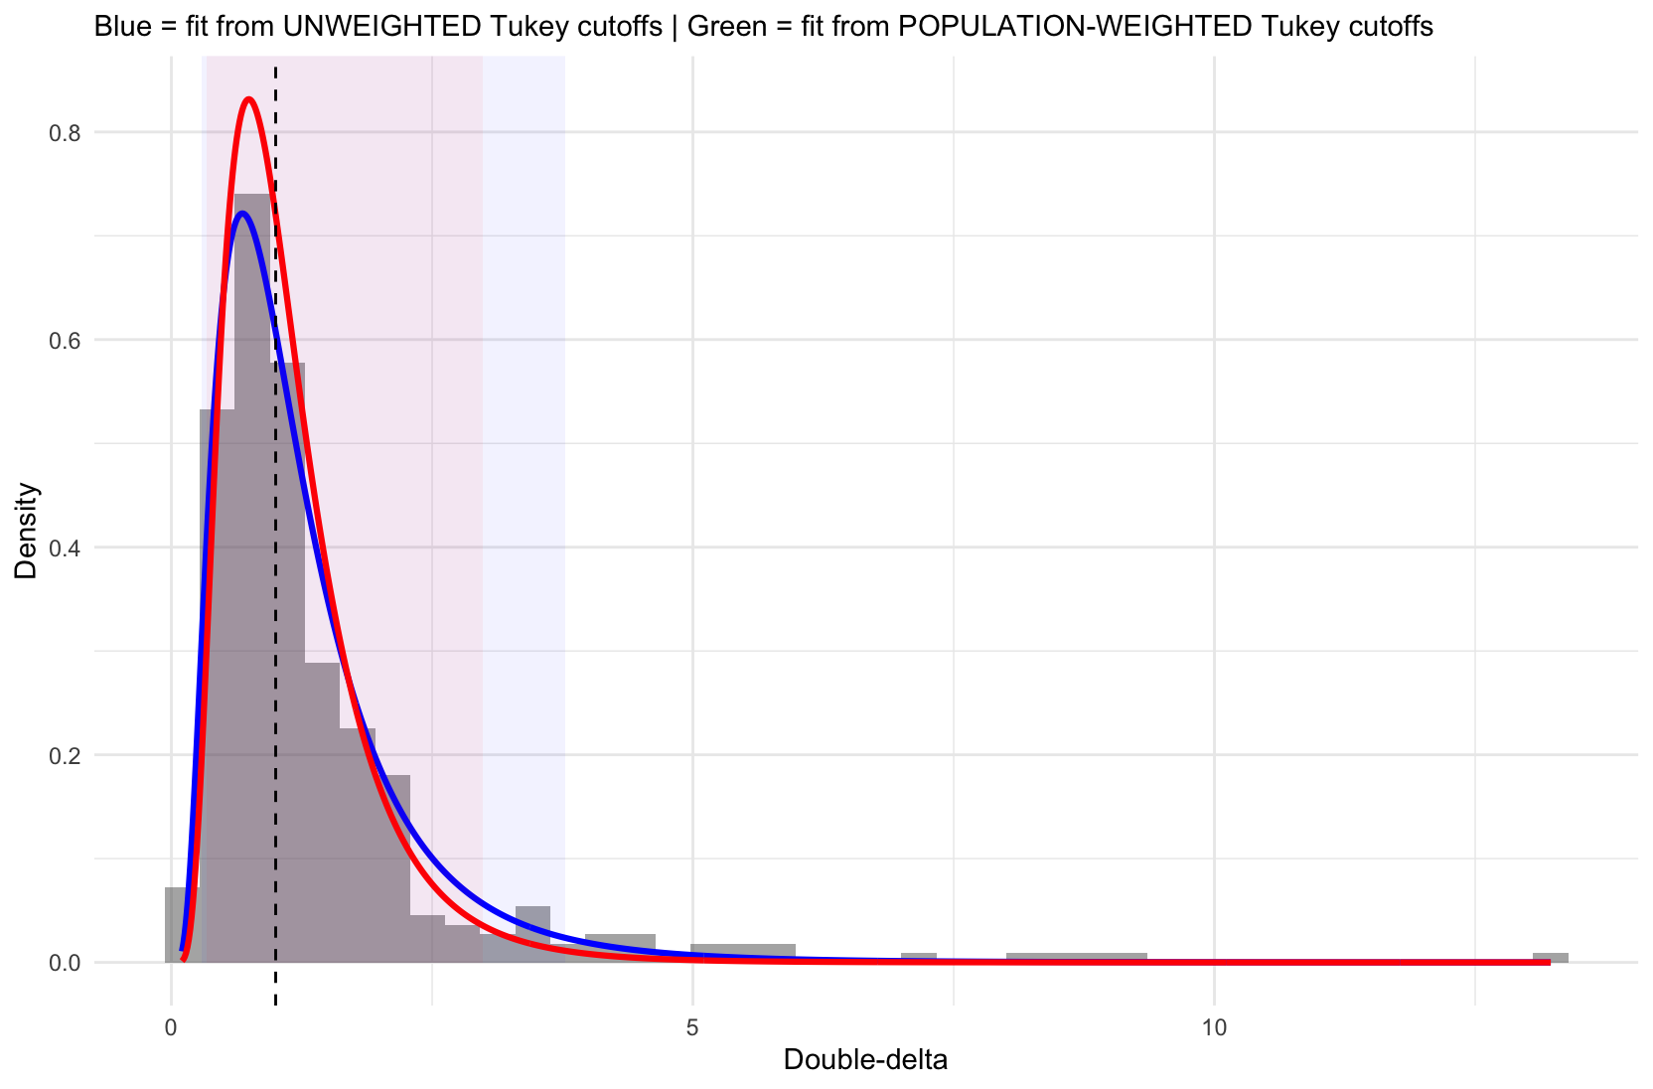
Figure 4. Empirical distribution and lognormal fits for the 5-year double-delta
Histogram of pooled 5-year double-delta values across metropolitan statistical areas, overlaid with fitted lognormal densities. The blue curve corresponds to the fit derived from unweighted Tukey cutoffs, and the red curve corresponds to the fit derived from population-weighted Tukey cutoffs. Shaded regions indicate the central reference intervals implied by each fit, and the dashed vertical line marks the median of the empirical distribution. Population weighting concentrates mass toward the central region and down-weights extreme curvature driven by smaller-population areas, while preserving the overall right-skewed structure of the distribution.

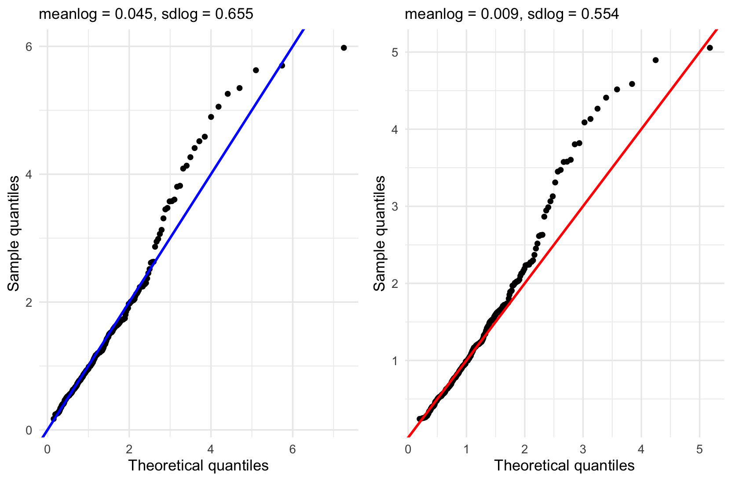
Figure 5. Lognormal Q–Q plots for the 5-year double-delta statistic
Quantile–quantile plots comparing empirical 5-year double-delta values to fitted lognormal reference distributions. The left panel shows the fit obtained after unweighted Tukey filtering (meanlog = 0.045, sdlog = 0.655), while the right panel shows the fit obtained after population-weighted Tukey filtering (meanlog = 0.009, sdlog = 0.554). Points represent empirical quantiles and solid lines represent the corresponding theoretical lognormal quantiles. Deviations in the upper tail reflect residual right-skewness in the double-delta distribution.

Likelihood Implementation Notes (How These Penalties Enter the Objective)

Each of these custom likelihoods in the shield_likelihoods.R script acts as a soft constraint: discouraging simulated trajectories whose medium-term growth behavior falls outside what was empirically observed. Concretely, each penalty is defined by a lognormal reference distribution described above (parameters like meanlog, sdlog or the interquartile range) fit from historical data, and then applied to ratios/double-deltas computed from the simulation.

1) How the simulation is mapped into the penalized quantity

At runtime, get.data.function(...) supplies:
- instructions (get.instr) for pulling simulated annual outcomes
- the evaluation years and window length (h = 5)
- reference-distribution parameters and tuning constants (band width, weights)

Then compute.function(sim, data, log=TRUE) pulls the simulated time series and constructs the derived statistic that will be penalized:
- Future change: rolling 5-year backward growth ratios
- U-turn: 5-year “double-delta” curvature, built from 5-year ratios

If no usable ratios/double-deltas exist in the specified time window, the contribution is set to neutral (0 on the log scale), so the penalty simply turns off rather than producing NA behavior.

2) The reference distribution defines a zero-penalty band

All penalties use the same shape: Zero inside a plausible band; lognormal tail penalty outside.

The band edges are derived from the reference distribution in one of two ways:

A. Symmetric band in log space (future.change)
Band edges are the lognormal points corresponding to:

Lower band: 𝓁 = exp(μ−kσ), Upper band: u = exp(μ+kσ)
where μ=meanlog, σ=sdlog, and k=sd.width ( which is set to 2, roughly a little more than the 95% CI).
B. Empirical quartile band (U.turn)
Band edges are set directly to empirical cutoffs Q25 and Q75 to accommodate fewer effective data points (but the tail shape is still evaluated using the lognormal density with meanlog/sdlog).

3) Penalty is a log-density difference anchored at the band edge

Let  be the lognormal density from the reference fit. For a simulated value  (a ratio or double-delta):
- if
- if
- if
This “anchoring” is why the penalty is exactly 0 at the band edges and non-positive outside, with increasingly extreme deviations becoming more negative.
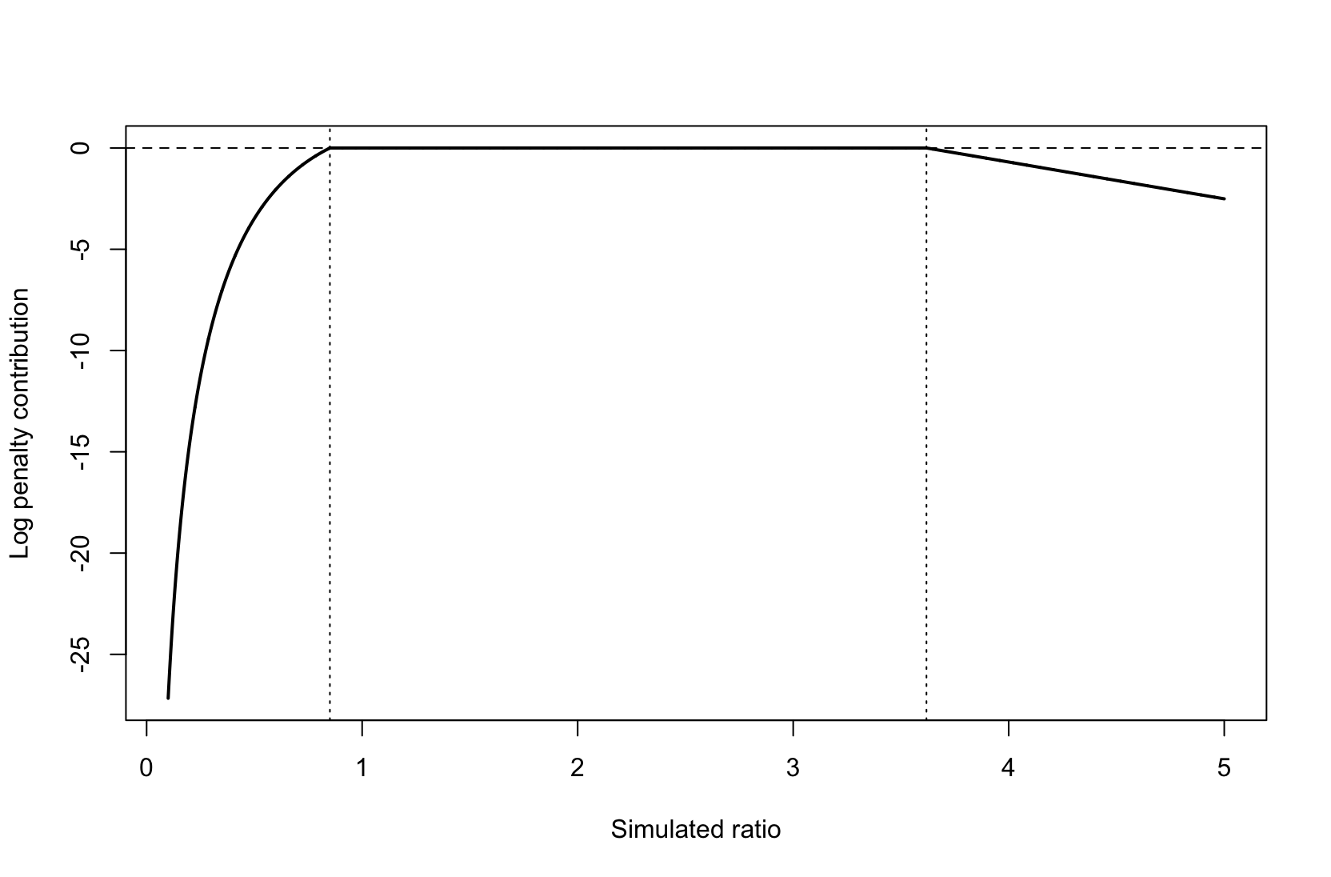
Figure 6. Shape of the lognormal band penalty used in the future-change and U-turn likelihoods. Simulated ratios or double-deltas x incur no penalty within the empirically defined band [ℓ, u] (dashed vertical lines). For the future-change likelihoods, the band edges are defined as ℓ = exp(μ − kσ) and u = exp(μ + kσ), where μ and σ are the mean and standard deviation of the fitted lognormal reference distribution on the log scale and k is a fixed band-width parameter. For the U-turn likelihoods, ℓ and u correspond to the empirical 25th and 75th percentiles (interquartile range) of the historical distribution. Deviations outside the band are penalized smoothly according to the lognormal reference density, with the penalty anchored to zero at the band edges and becoming increasingly negative for more extreme deviations. In this illustrative example, the reference distribution uses meanlog = 0.562 and sdlog = 0.362, with k = 2.

4) How penalties aggregate across time (and strata)
- Unstratified versions: compute penalties across all usable years and sum them.
- Stratified versions: compute the same yearwise penalties separately per sex by race stratum, apply count/reliability guardrails, then sum across strata.

5) How weighting scales the constraint strength
After summing the pointwise penalties, the total is scaled by:
- a global tuning weight (data$weight)
- an inverse-variance factor based on the reference uncertainty (1/sdlog^2)
So the effective multiplier is:
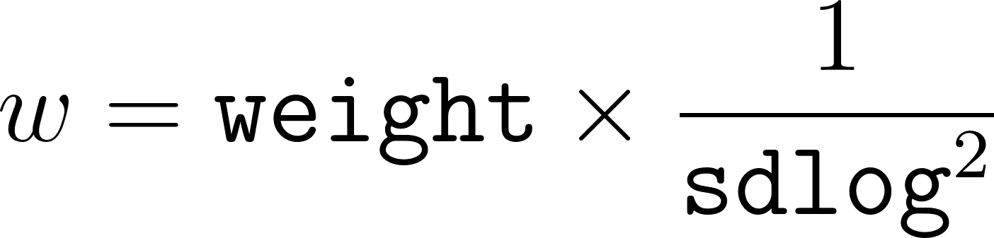

6) Practical interpretation for functions
- future.change.likelihood / future.change.strata.likelihood: penalize simulated 5-year growth ratios that leave the empirically plausible envelope (defined by meanlog/sdlog and the ±sd.width band).
- U.turn.likelihood / U.turn.strata.likelihood: penalize simulated curvature (double-delta) when it falls outside typical historical curvature, using Q25/Q75 as the “safe” band and the lognormal density to score tails.

